Project Design Phase-II

Data Flow Diagram & User Stories

Date | 06 July 2026
Project Domain | ServiceNow
Project Name | Smart Library Request Workflow in ServiceNow
Maximum Marks

Data Flow Diagrams:

A Data Flow Diagram (DFD) shows how data moves within the Smart Library Request Workflow system. A neat and clear DFD can depict the right amount of the system
requirements graphically, it explains how users submit requests, how the system processes them, and how results are delivered

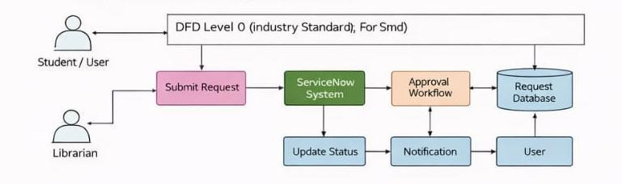

User Stories

User Type | Functional Requirement | User Story | Acceptance Criteria | Priority | Release
Student | Book  Request | As a user, I can submit a book request  online | Request is submitted successfully | High | Sprint-1
Student | Track Status | As a user, I can track my  request status | Status is visible in  portal | High | Sprint-1
Librarian | Approve Request | As a librarian,  I can  approve/reject requests | Request status  updated correctly | High | Sprint-1
Admin | Manage System | As an admin, I can manage users and  requests | System runs without | Medium | Sprint-2
Student | Notification | As a user, I receive  notification for updates | Email/SMS notification received | High | Sprint-1

Reference: https://example-network.smartlibrarysolution/data-flow-diagram

